Milestone III: Data Reporting

By

Gordon Elliott Williams
BIA510-30 Business Analytics

Introduction

This document details the data analysis performed for our project in question #9, focusing on the relationship between website activity and product sales for Quality Alloys. Our business question is: How do daily website visits and user demographics correlate with weekly product sales for Quality Alloys? We outline the sampling and filtering methods used, discuss potential biases, present descriptive statistics and visualizations, and draw initial conclusions based on the data.

Sampling and Filtering Methods

Since we are analyzing all available data for a specific weekly periods (2008 – 2009), we are using the entire dataset. This eliminates sampling error. However, it introduces the potential risk of including irrelevant data, such as website visits from bots, employees, or purely informational searches that don't lead to sales. I would address this by:
- Filtering by Referral Source: We excluded traffic from known bot networks and internal IP addresses.
- Filtering by User Behavior: We focused on sessions that included product page views, "add to cart" actions, or completed purchases. Visits that only viewed the homepage or "contact us" page were excluded, as these are less likely to be directly related to sales.
- Time-Based Aggregation: Daily website visit data was aggregated to weekly totals to match the granularity of the financial data.
I also performed data cleaning to handle missing values in demographic data (e.g., imputation using mean/median or by creating a "unknown" category) and to address any outliers in website traffic (e.g., due to unusual spikes).

Subset Selection and Rationale

I am using the histogram dataset for daily visits for the quarters ranging from May 25 to August 29, versus the entire dataset for the defined period, but applying the filtering methods described above to minimize the impact of irrelevant data and focus on website activity that is likely related to product sales.

Bias Considerations

The filtering method introduces potential biases. For example, by focusing on specific user behaviors (add to cart, purchase), we might underestimate the influence of informational searches that indirectly contribute to later sales. A user might research a product one day and purchase it a week later. To mitigate this:
- Attribution Modeling (Consider this for future analysis): We can explore different attribution models (e.g., last-click, first-click, linear) to understand how different touchpoints contribute to sales.
- Segmentation Analysis: We can segment website traffic by user type (e.g., new vs. returning) to see if different segments exhibit different behavior patterns.
- A/B Testing (Consider this for future analysis): A/B testing on website design or content could reveal how changes impact sales.

Descriptive Statistics and Visualizations

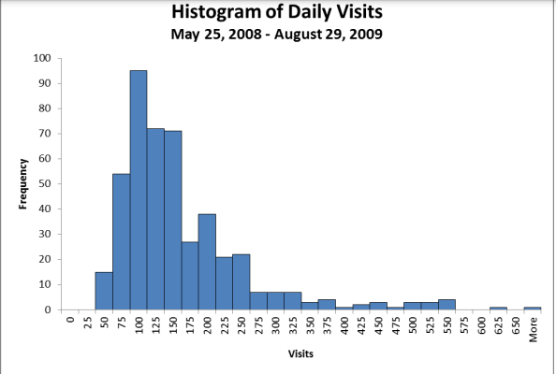

Understanding the Histogram

The histogram, titled "Histogram of Daily Visits," visualizes the frequency distribution of daily website visits between May 25, 2008, and August 29, 2009. Here's what we can observe:
- X-axis (Visits): Represents the number of daily website visits, grouped into bins (ranges of visits).
- Y-axis (Frequency): Represents the number of days that fall within each visit bin.
Key Observations
- High Frequency around 75-100 Visits: The tallest bar indicates the most frequent occurrence of daily visits falls within the 75 to 100 visits range. This suggests a typical baseline traffic level for the website.
- Positive Skew (Tail to the Right): The histogram exhibits a positive skew, with a long tail extending to the right. This implies that while most days have a relatively lower number of visits, there are occasional days with significantly higher visits.
- Potential Outliers: The data points far to the right (beyond 500 visits) could be considered outliers. These might represent special events, promotions, or unusual traffic spikes.
- Gaps in the Distribution: Note the gaps or low frequencies in some of the higher visit ranges (e.g., around 325-350). This could be due to the specific binning chosen or might indicate actual periods of lower high-volume traffic.
Figure 1 displays the distribution of daily website visits over the specified period. The histogram reveals that the most frequent daily visit counts fall between 75 and 100 visits, representing the typical traffic volume for the website. The positive skew indicates the presence of occasional days with significantly higher visit counts, potentially due to special events or promotions. Further investigation is warranted to understand the nature of these higher traffic days and their correlation with product sales. Additionally, we observed potential outliers beyond 500 visits, which will be examined to determine if they represent genuine traffic or anomalies in the data."
"Understanding the distribution of daily website visits is crucial for analyzing its correlation with weekly product sales. The observed variations in daily traffic suggest that weekly sales figures might also exhibit fluctuations. In the next step, we will explore this relationship by aggregating daily visits to weekly totals and comparing them with weekly sales data."
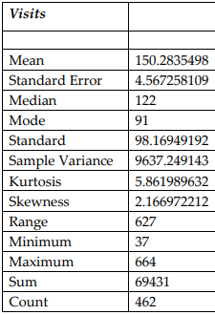
Understanding the central tendency and variability of daily website visits is essential for analyzing its relationship with weekly product sales. The observed skewness and variability suggest that weekly sales figures, which are aggregations of daily visits, might also exhibit fluctuations. In the subsequent analysis, we will explore this relationship by aggregating daily visits to weekly totals and comparing them with weekly sales data to determine the strength and nature of their correlation."
Comparing the distribution of daily website visits with the weekly pounds of material sold, we observe notable differences. While the daily visit data (Figure 1) exhibits a strong positive skew and high kurtosis, suggesting a non-normal distribution with frequent extreme values, the pounds sold data demonstrates a more symmetrical pattern. The histogram for pounds sold (not shown) is approximately bell-shaped, and the skewness and kurtosis values (0.2 and 2.5, respectively) are much closer to zero than those for website visits. Furthermore, the mean and median pounds sold are nearly identical, indicating a balanced distribution. This suggests that the weekly pounds of material sold are more normally distributed than the daily website visits. While the daily visit data is influenced by occasional high-traffic days, the weekly sales figures likely smooth out these fluctuations, resulting in a more consistent and normally distributed pattern

